How to create notebook in azure synapse workspace

1. Go to azure synapse workspace
2. Create spark pool
3. Go to the develops
4. go to +
5. create notebook

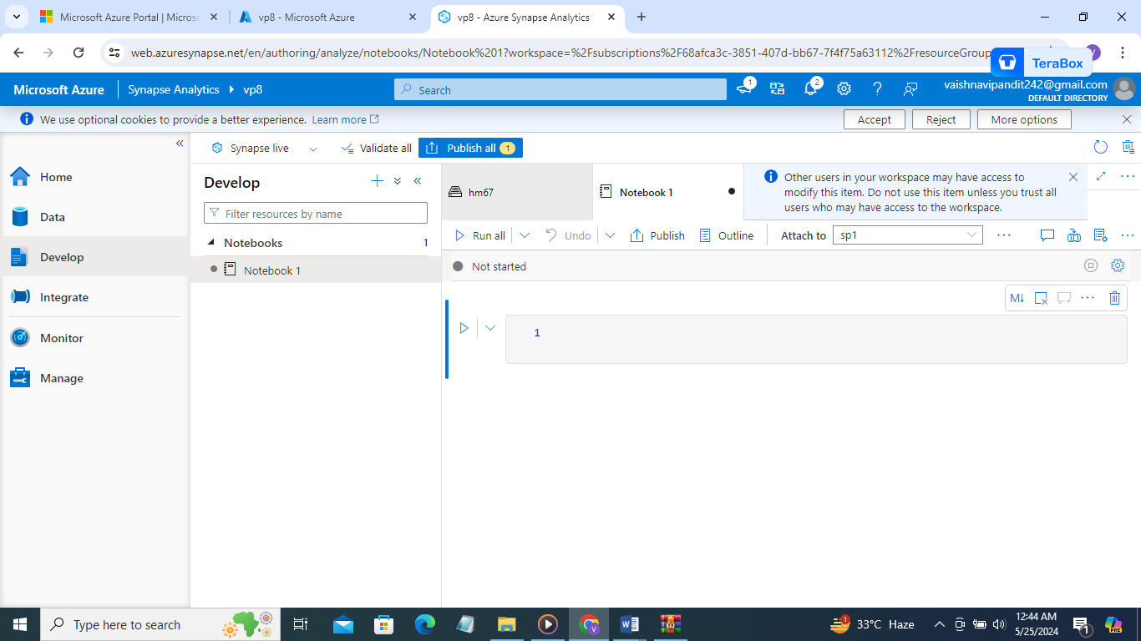

1. in attach add the spark pool

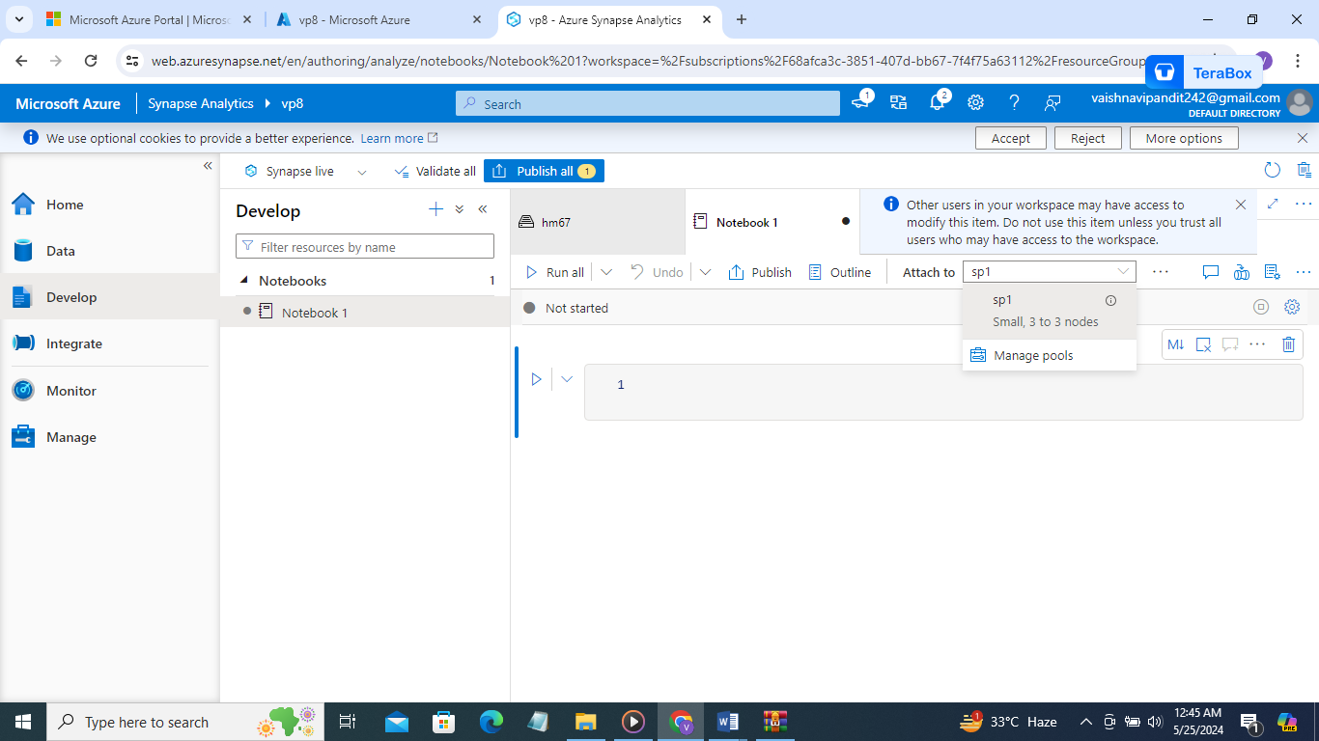

1. now add the mount point

for adding mount point use

mssparkutils.fs.mount(

‘abfss://adls_name@storage_name.dfs.core.windows.net’,

‘/mnt/data’,

{‘accountkey’:’key’})

For account